# **Shopping Hut**

## **1. Description**

Shopping hut is a web application for online shopping. It will enable the customers to buy large

variety of products in reasonable amount of time. It will enable the users to get access to

different sale items and to order the products of their choice without any need to visit the market.

Registration of users is required for utilizing different sale options. It will allow registered users

to order different items and to purchase the products. Once the order is placed the customer

information will be checked for verification and then order will be placed. Customers can make

payment through cash. The admin of the system will keep record of all the items that are

available for sale and the items whose order has been placed and the products that have been

sold. The admin can also add or remove a sale item.

## **2. Goals**

The goals of the application are:

* To enable the customers to buy large variety of products in reasonable amount of time
* without the need to visit stores.
* To extend the business by selling the products to large number of customers.
* To provide variety of products to the customers.
* To provide flexible ordering options for the ease of users.
* To ensure customer satisfaction through better service.
* To keep customer information safe and secure.

## **3. Functional Requirements**

1. System will allow the user to sign-up.
2. System will allow the user to login.
3. System will allow the user to logout.
4. System will allow the user to view items.
5. System will allow the user to display categories.
6. System will allow the user to view cart.
7. System will allow the user to view order.
8. System will allow the user to add items to cart.
9. System will allow the user to remove items from cart.
10. System will allow the user to buy product.
11. System will allow the user to view order history.
12. System will allow the admin to add product.
13. System will allow the admin to remove product.
14. System will allow the admin to update product.

# **4. GUI**

## **4.1 Home Page**

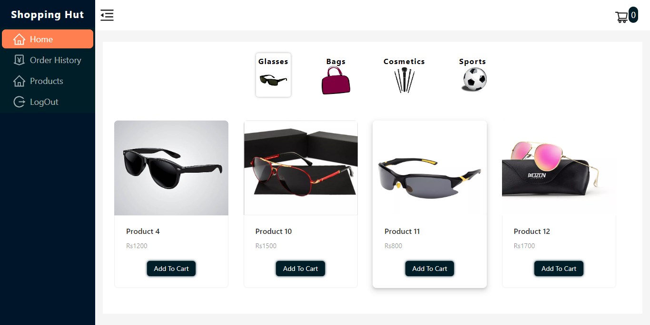

## **4.2 Register**

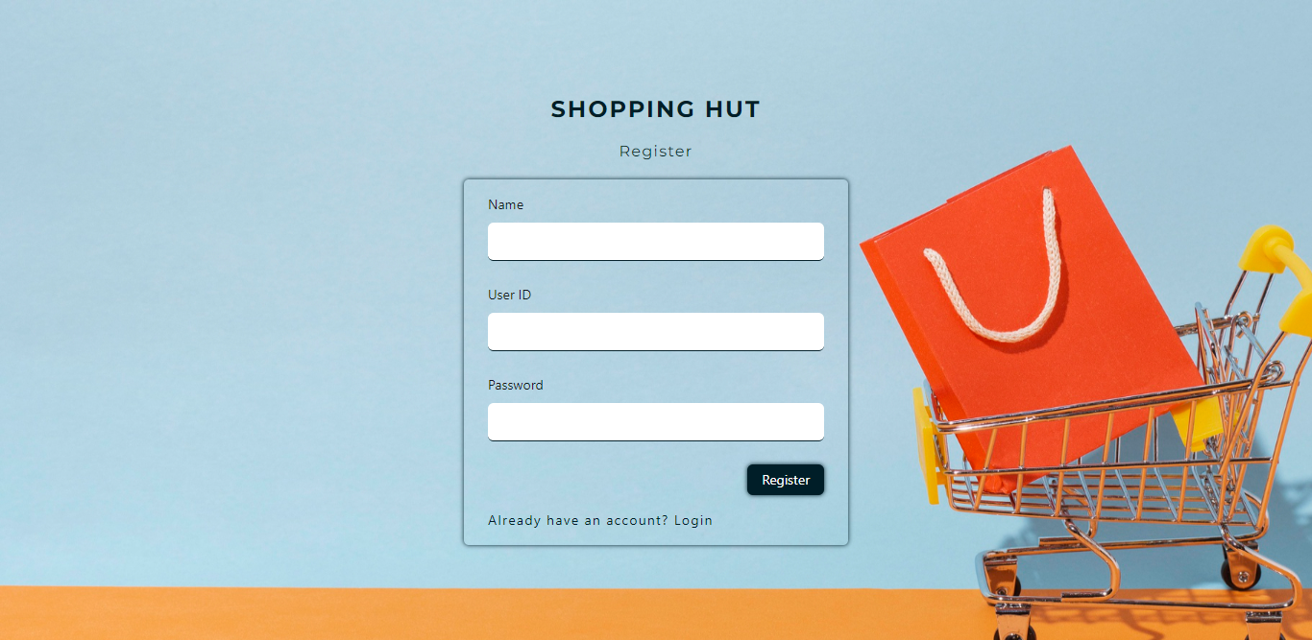

## **4.3 Login**

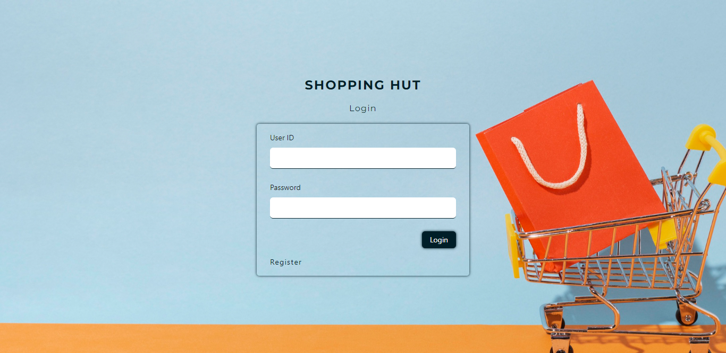

## **4.4 All Products**

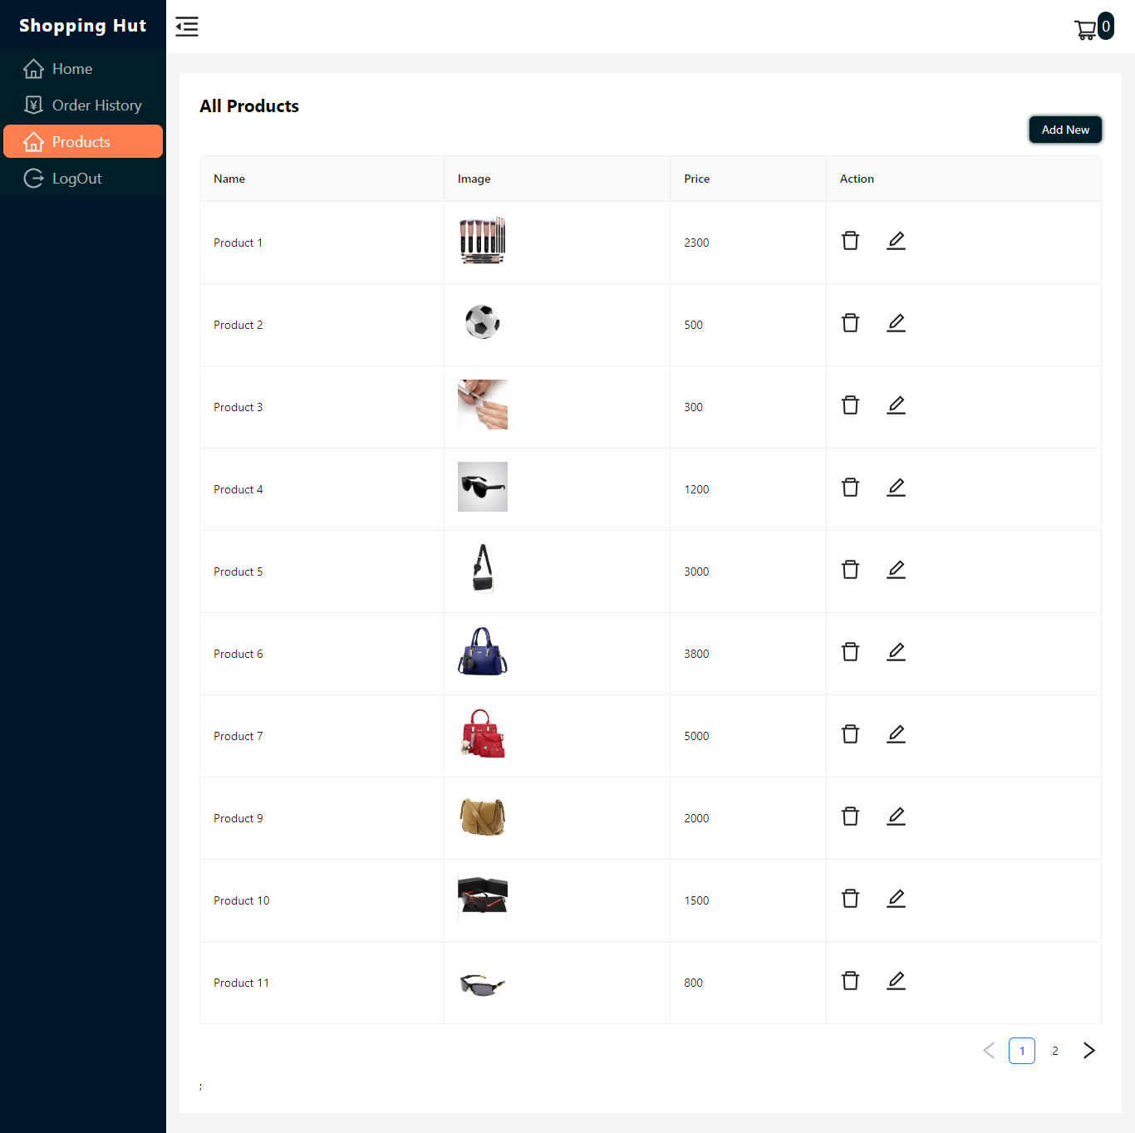

## **4.5 View Cart**

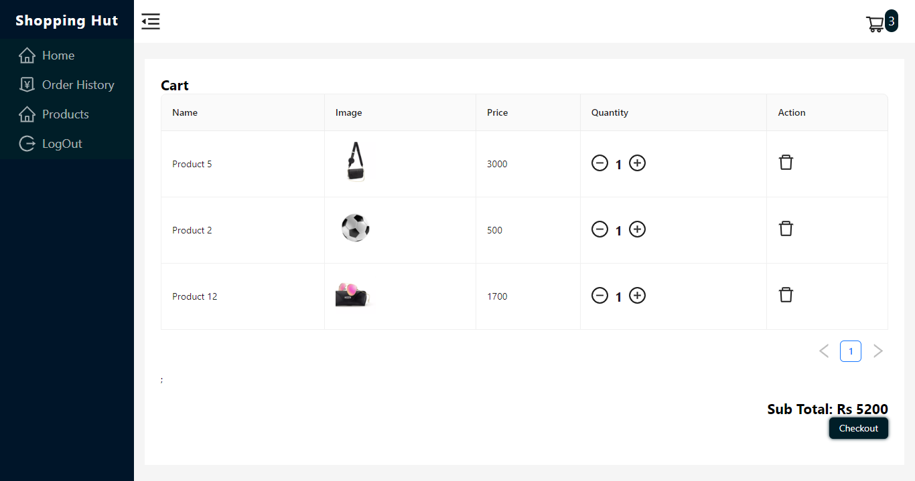

## **4.6 Checkout**

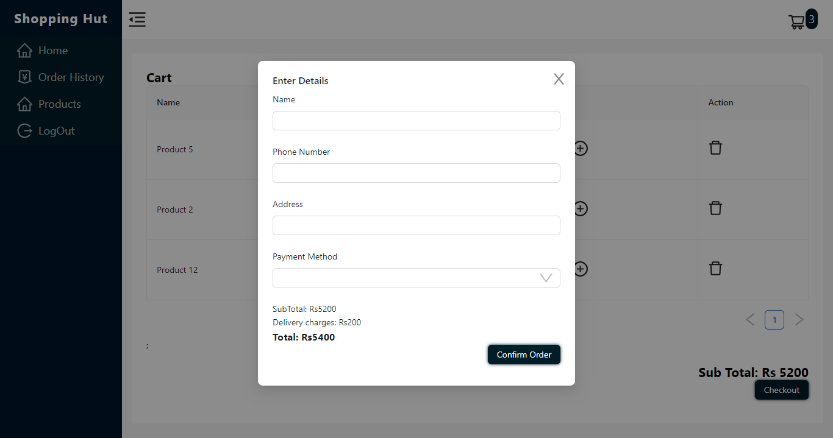

## **4.7 Order History**

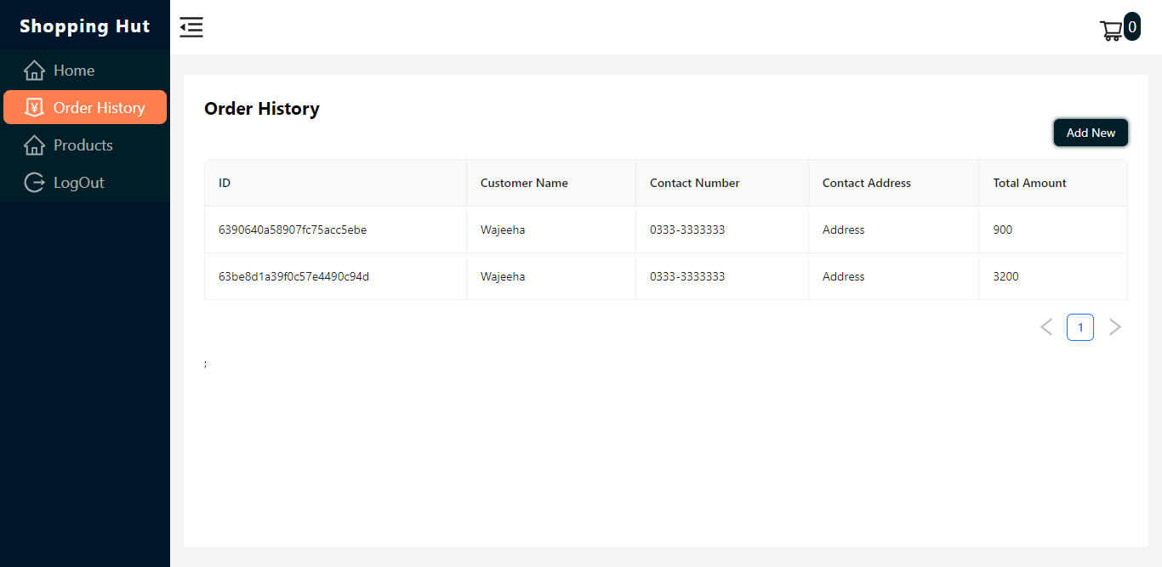

## **4.8 Edit Product**

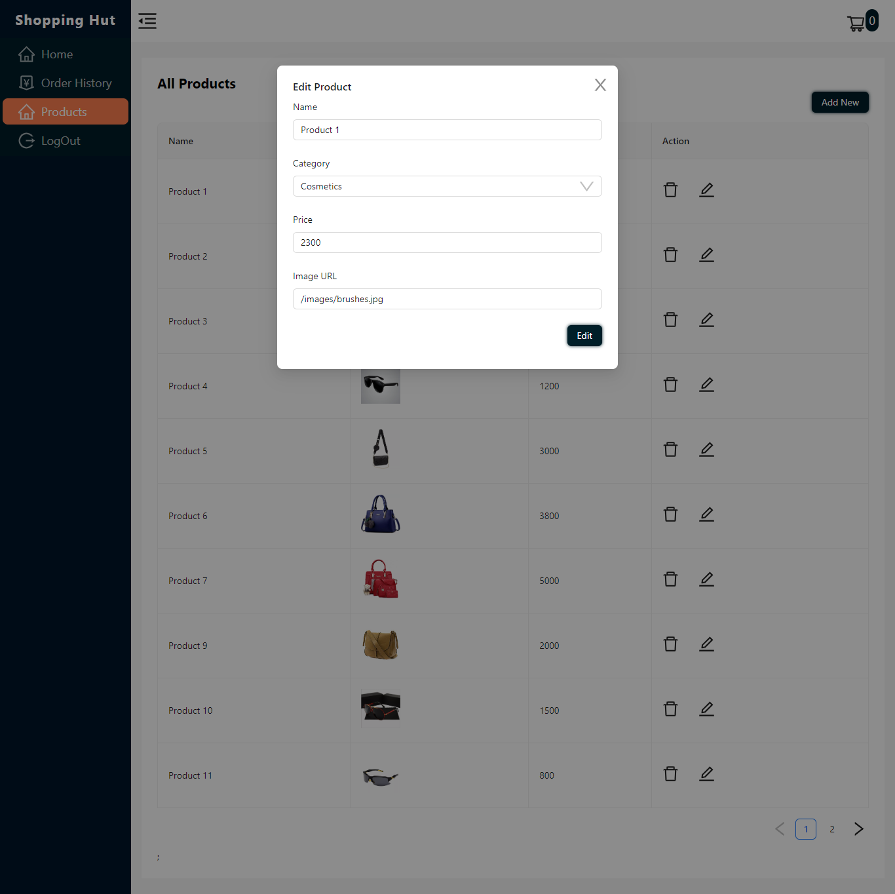

## **4.9 Add Product**

